NEVARA MRV Platform
NEVARA Ecological Intelligence Report
Tahir · River Restoration · 2026

Confidential Ecological Monitoring Report · Generated 12 June 2026 · NEVARA MRV v2.0

Executive Summary
Ecological assessment for Tahir, Karnataka, India, based on Landsat 8 Collection 2 SR imagery for the 2026-04-27 to 2026-06-11 window. Current condition: The composite ecosystem health index of 43/100 reflects a fair overall ecological condition. Note: some indices used fallback imagery this cycle, which slightly reduces confidence. The composite ecosystem health index stands at 43 out of 100, with NDVI down 65.2% versus baseline. Key improvements: no statistically notable positive shifts were detected this cycle relative to the available baseline. Key risks: mean NDVI of 0.191 indicates sparse vegetation. The area shows limited live canopy relative to a healthy ecosystem baseline. vegetation indicators have declined relative to earlier cycles over 7 monitored years (2020–2026). The NDVI trajectory is stable, which warrants closer attention. water availability indicators show signs of stress in the monitored area. Mean canopy moisture (NDMI) of -0.193 is below the stress threshold of −0.15. ecological risk is rated 58/100 (elevated urgency). The site is stable but shows risk factors that warrant attention. risk indicators recommend a increased monitoring cadence, above the current quarterly schedule. Recommended attention areas: Investigate causes of low canopy density and consider targeted planting or protective interventions. Prioritise a field check to identify drivers of vegetation loss (drought, clearing, salinity, or grazing pressure). Assess hydrological inputs and consider whether supplementary watering or tidal/flow restoration is needed. Address limiting factors (moisture, soil, slope) before committing major restoration resources. Monitoring outlook: Risk indicators recommend a increased monitoring cadence, above the current quarterly schedule. The next monitoring cycle is scheduled for 9/9/2026. All statements above are derived solely from the evidence metrics for this monitoring run and carry traceable source references.
Ecological Intelligence KPI Summary
Metric | Value
Ecosystem Health Index | 42.9 / 100
Vegetation Density (NDVI) | 0.1912
Ecological Risk Score | 57.66 / 100
Restoration Suitability Score | 30.08 / 100
Vegetation Trend | stable
Annual NDVI Rate of Change | 0.0004 NDVI/yr
Intervention Urgency | ELEVATED
Monitoring Cycles Completed | 7
Evidence Validation Status | WARNING (97 / 100)

1. Project Overview
This monitoring cycle was conducted using Landsat 8 Collection 2 SR imagery. Analysis type: scheduled. A cloud-cover filter of 30% was applied to ensure data quality. All spectral indices and derived metrics were calculated from atmospherically corrected surface reflectance data.
Project & Monitoring Details
Metric | Value
Project Name | Tahir
Organisation | Alice Johnson
Location | Karnataka, India
Ecosystem Type | River Restoration
Site Area | 4.4346 ha
Monitoring Cycle Type | scheduled / edaa5fa5-3a8e-4428-adf8-8db70f559a61
Primary Satellite Dataset | Landsat 8 Collection 2 SR
Analysis Period | 2026-04-27 → 2026-06-11
Cloud Cover Filter Applied | 30%
Report Generated | 12 June 2026

2. Project Boundary & Site Overview
Boundary & Spatial Metrics
Metric | Value
Site Area | 4.4346 ha
Site Area (sq m) | 44346 m²
Perimeter | 0.9704 km
Centroid Latitude | 16.1453°
Centroid Longitude | 75.929°

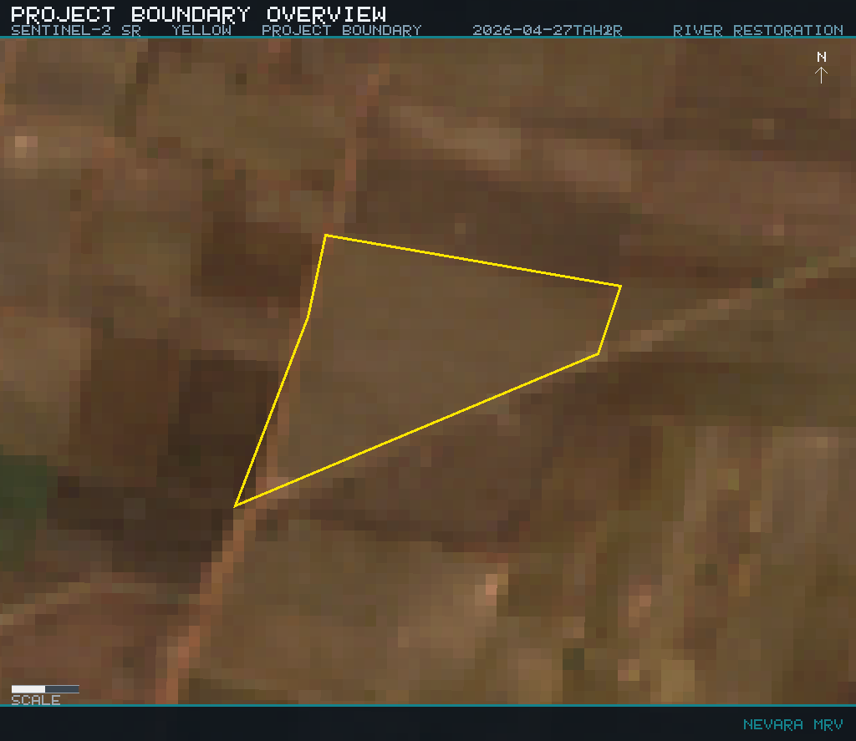
Figure: Figure 1 — Project Boundary: GIS-delineated site extent with terrain context evidence asset
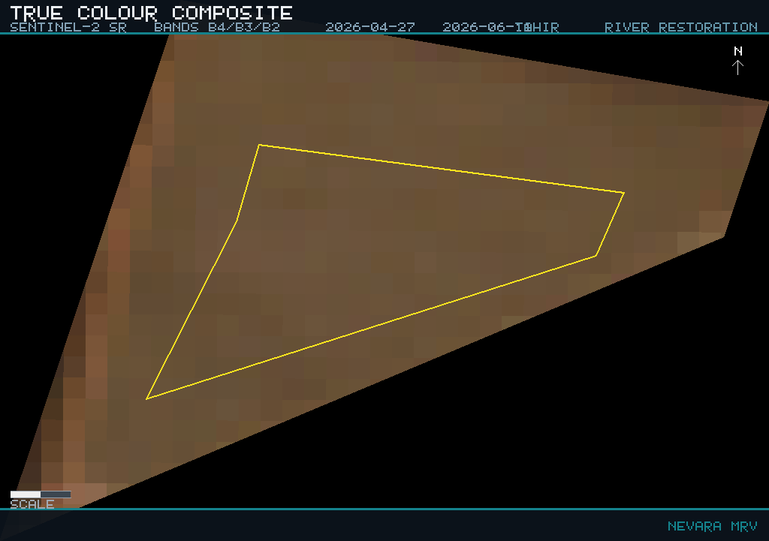
Figure: Figure 2 — True Colour Composite: Sentinel-2 SR (B4/B3/B2) visual canopy and land-cover verification evidence asset

3. Vegetation Health Analysis
Evidence Summary: Mean NDVI = 0.191; Mean EVI = 0.096; NDVI trend direction = stable; Trend strength (NDVI/yr) = 0.0004; NDVI change vs baseline = -65.2 %; Mean NDMI (canopy moisture) = -0.193; Mean NDWI (surface water) = -0.332. Interpretation: Mean NDVI of 0.191 indicates sparse vegetation. The area shows limited live canopy relative to a healthy ecosystem baseline. Vegetation indicators have declined relative to earlier cycles over 7 monitored years (2020–2026). The NDVI trajectory is stable, which warrants closer attention. Water availability indicators show signs of stress in the monitored area. Mean canopy moisture (NDMI) of -0.193 is below the stress threshold of −0.15. Recommendation: Investigate causes of low canopy density and consider targeted planting or protective interventions. Prioritise a field check to identify drivers of vegetation loss (drought, clearing, salinity, or grazing pressure). Assess hydrological inputs and consider whether supplementary watering or tidal/flow restoration is needed.
Multi-Index Vegetation Health Assessment
Metric | Value
NDVI Mean (Vegetation Density) | 0.1912
NDVI Minimum | 0.1312
NDVI Maximum | 0.2512
EVI Mean (Enhanced Vegetation) | 0.0965
SAVI Mean (Soil-Adjusted Vegetation) | 0.1053
NDMI Mean (Moisture Index) | -0.1927
NBR Mean (Burn Ratio) | -0.1071
BSI Mean (Bare Soil Index) | 0.2342

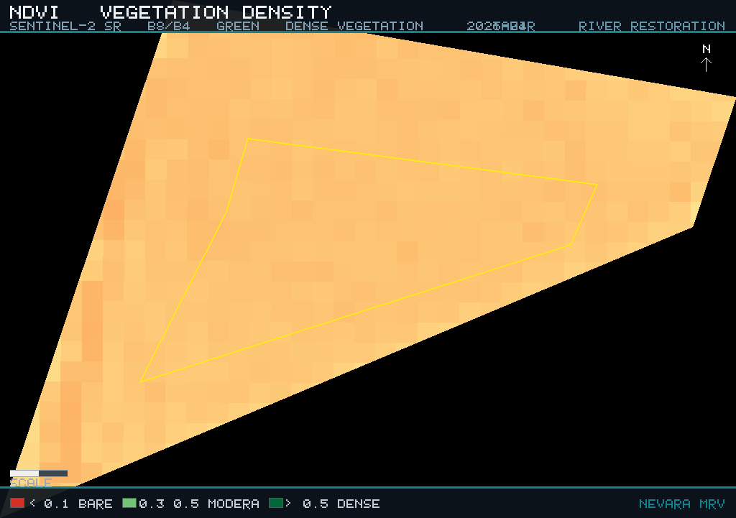
Figure: Figure 3 — NDVI Vegetation Density Map: Sentinel-2 SR (B8/B4) · Dark green = dense canopy (NDVI > 0.6), red = bare or stressed cover (NDVI < 0.1) evidence asset

4. Water Content & Moisture Analysis
Water content and moisture conditions across the project site were assessed using the Normalised Difference Water Index (NDWI) and Normalised Difference Moisture Index (NDMI) derived from Sentinel-2 surface reflectance imagery. NDWI of -0.332 indicates dry or water-stressed conditions across the majority of the site. NDMI of -0.193 characterises foliar water content and drought stress in the vegetation canopy. Open water and wetland areas comprise 0.0% of the classified land cover. Hydrological stress score: 12/100.
Water & Moisture Index Summary
Metric | Value
NDWI Mean (Water Index) | -0.3321
NDMI Mean (Moisture Index) | -0.1927
Water Body Coverage | 0%
Hydrological Stress Score | 12.25 / 100
Water Retention Score | 87.75 / 100

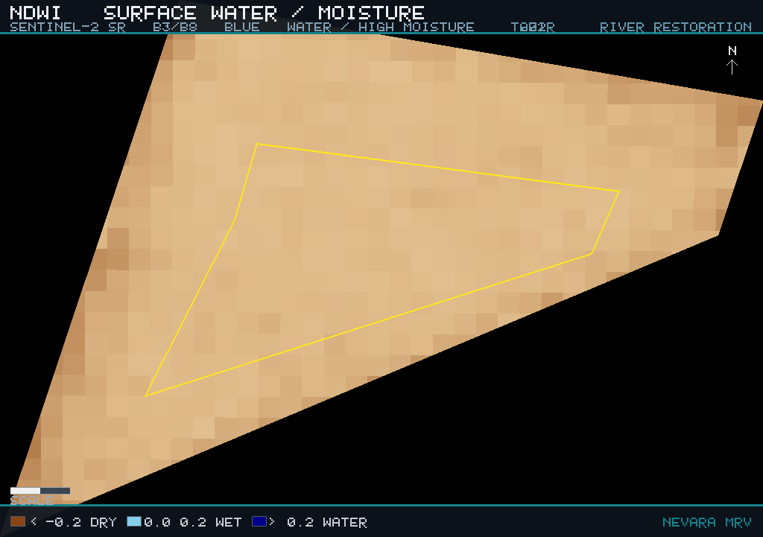
Figure: Figure 4 — NDWI Moisture Map: Sentinel-2 SR (B3/B8) · Blue = high moisture / open water, brown = dry stress evidence asset

5. Land Surface Temperature Analysis
Land Surface Temperature (LST) — Landsat 8/9 Thermal Infrared
Metric | Value
LST Mean | N/A
LST Minimum | 48.58 °C
LST Maximum | 52.52 °C
Thermal Range | 3.94 °C
Source Dataset | LANDSAT/LC08+LC09/C02/T1_L2

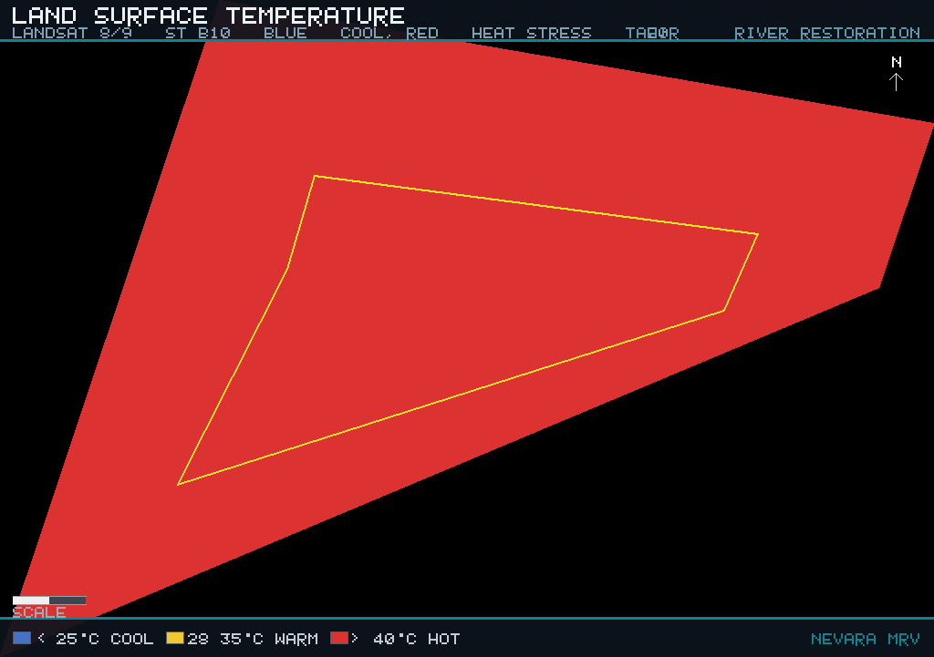
Figure: Figure 5 — Land Surface Temperature Map: Landsat 8/9 Collection 2 (ST_B10) · Blue = cool (< 25 °C), orange-red = thermal stress (> 40 °C) evidence asset

6. Land Use & Cover Classification
Land use and land cover composition was classified using the Google Dynamic World v1 dataset. Vegetation cover comprises 100.0% of the analysis area. Open water and wetland areas account for 0.0%. Built-up and impervious surfaces occupy 0.0%. Bare and sparsely vegetated ground covers 0.0%.
Land Use / Land Cover Composition — Dynamic World v1
Metric | Value
Vegetation Cover | 100%
Open Water & Wetland | 0%
Barren / Sparse Vegetation | 0%
Built-up / Impervious | 0%
Other Land Cover | 0%
Classification Dataset | GOOGLE/DYNAMICWORLD/V1

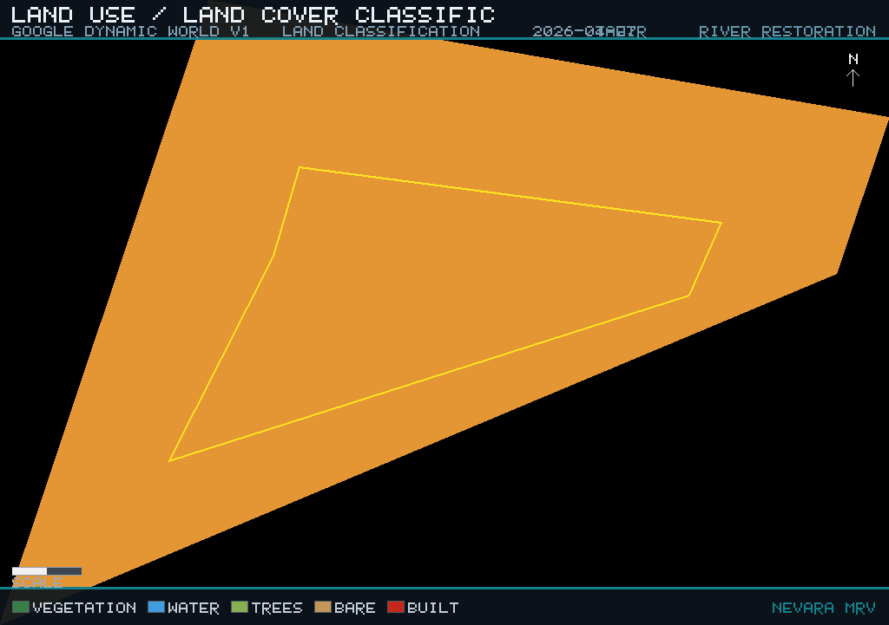
Figure: Figure 6 — Land Cover Classification: Google Dynamic World v1 · Green = vegetation, blue = water, grey = built-up, tan = bare ground evidence asset

7. Multi-Year NDVI Trend Analysis
Evidence Summary: NDVI trend direction = stable; Trend strength (NDVI/yr) = 0.0004; NDVI change vs baseline = -65.2 %. Interpretation: Vegetation indicators have declined relative to earlier cycles over 7 monitored years (2020–2026). The NDVI trajectory is stable, which warrants closer attention. Recommendation: Prioritise a field check to identify drivers of vegetation loss (drought, clearing, salinity, or grazing pressure).
Historical Vegetation Trend Summary
Metric | Value
Baseline Year | 2020
Current Year | 2026
Trend Direction | STABLE
Annual NDVI Rate of Change | 0.0004 NDVI / year
Years in Analysis Window | 7
Dataset | Sentinel-2 SR Harmonized (COPERNICUS/S2_SR_HARMONIZED)

Annual NDVI Trajectory
Metric | Value
Year | NDVI Mean | Year-on-Year Change
2020 | 0.2092 | Baseline year
2021 | 0.2127 | 0.0035
2022 | 0.2402 | 0.0275
2023 | 0.231 | -0.0092
2024 | 0.2513 | 0.0203
2025 | 0.2251 | -0.0262
2026 | 0.1939 | -0.0312

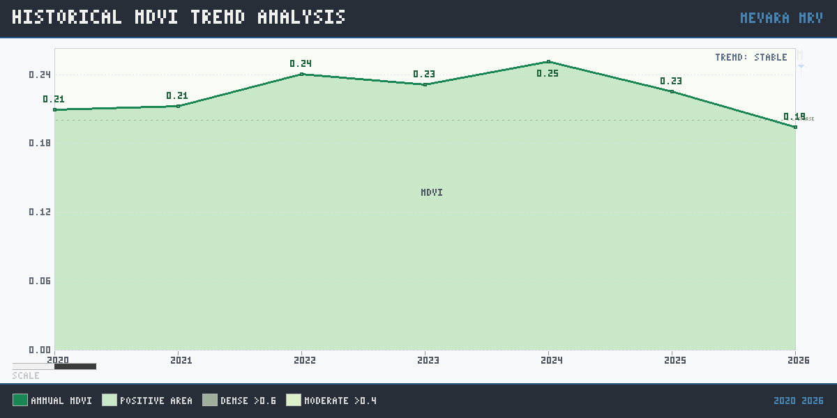
Figure: Figure 7 — Annual NDVI Trend: Sentinel-2 SR median composites with vegetation health threshold bands (dense > 0.6, moderate > 0.4, sparse > 0.2) evidence asset

8. Terrain Hydrology & Drainage Assessment
Evidence Summary: Runoff risk = low; Hydrological stress score = 12 /100; Mean slope = n/a. Interpretation: Runoff risk is rated low (stress score 12/100), indicating stable hydrological conditions. Recommendation: No specific action is required for this indicator in the current cycle.
Terrain Hydrology — SRTM 30m Digital Elevation Model
Metric | Value
Mean Elevation | N/A
Minimum Elevation | 524 m
Maximum Elevation | 529 m
Mean Terrain Slope | N/A
Slope Class | GENTLE
Surface Runoff Risk | LOW
Water Retention Score | 87.75 / 100
Hydrological Stress Score | 12.25 / 100

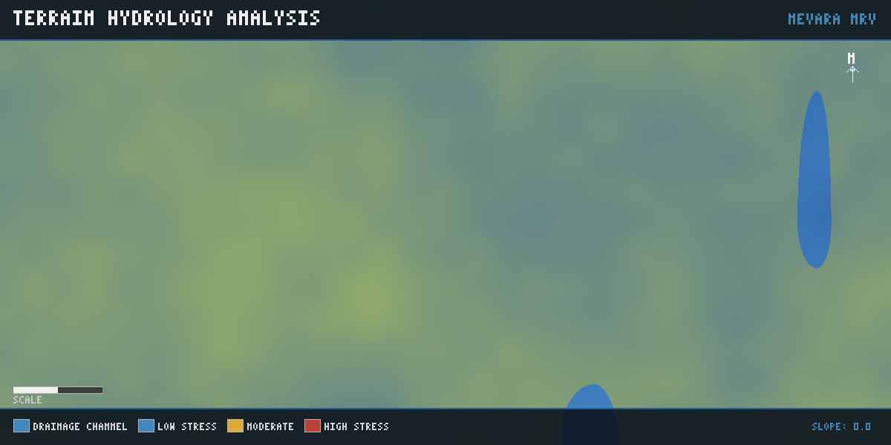
Figure: Figure 8 — Terrain Hydrology Map: SRTM 30m DEM · Blue = drainage channels / low runoff zones, green-yellow = moderate terrain, red = high hydrological stress evidence asset

9. Ecological Restoration Suitability
Evidence Summary: Restoration suitability = 30 /100; Restoration priority = low. Interpretation: Restoration suitability scores 30/100 (low priority). Site conditions currently constrain restoration potential. Recommendation: Address limiting factors (moisture, soil, slope) before committing major restoration resources.
Restoration Suitability Assessment — Multi-Index Composite
Metric | Value
Overall Suitability Score | 30.08 / 100
Priority Classification | LOW
Vegetation Condition Score | 34.37 / 100
Moisture Condition Score | 12.74 / 100
Soil Condition Score | 29.46 / 100
Terrain Slope Condition | 50 / 100
Methodology Version | restoration-suitability-v2.0

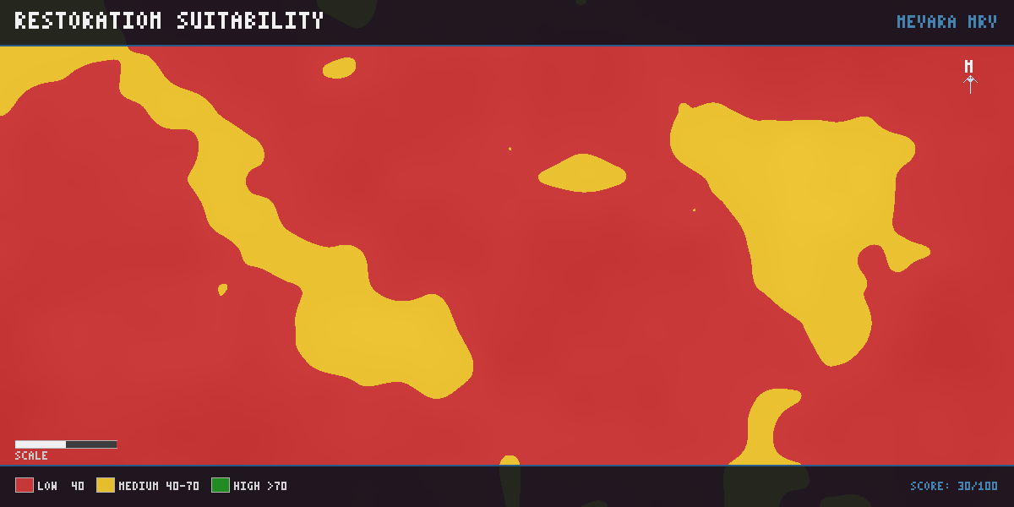
Figure: Figure 9 — Restoration Suitability Map: Multi-index composite (NDVI + NDMI + BSI + terrain slope) · Dark green = high suitability (> 70), red = low suitability (< 40) evidence asset

10. Ecological Risk Assessment
Evidence Summary: Overall ecological risk = 58 /100; Intervention urgency = elevated; Monitoring priority = increased. Interpretation: Ecological risk is rated 58/100 (elevated urgency). The site is stable but shows risk factors that warrant attention. Recommendation: Maintain standard monitoring and track whether risk drivers trend upward in the next cycle.
Ecological Risk — Weighted Multi-Domain Assessment
Metric | Value
Overall Ecological Risk Score | 57.66 / 100
Vegetation Risk Component | 76.4 / 100
Moisture Risk Component | 94.15 / 100
Thermal Risk Component | 50 / 100
Hydrological Risk Component | 12.25 / 100
Historical Trend Risk | 45 / 100
Restoration Priority | MODERATE
Intervention Urgency | ELEVATED
Monitoring Priority | INCREASED
Confidence Score | 95 / 100
Methodology Version | ecological-risk-v1.0

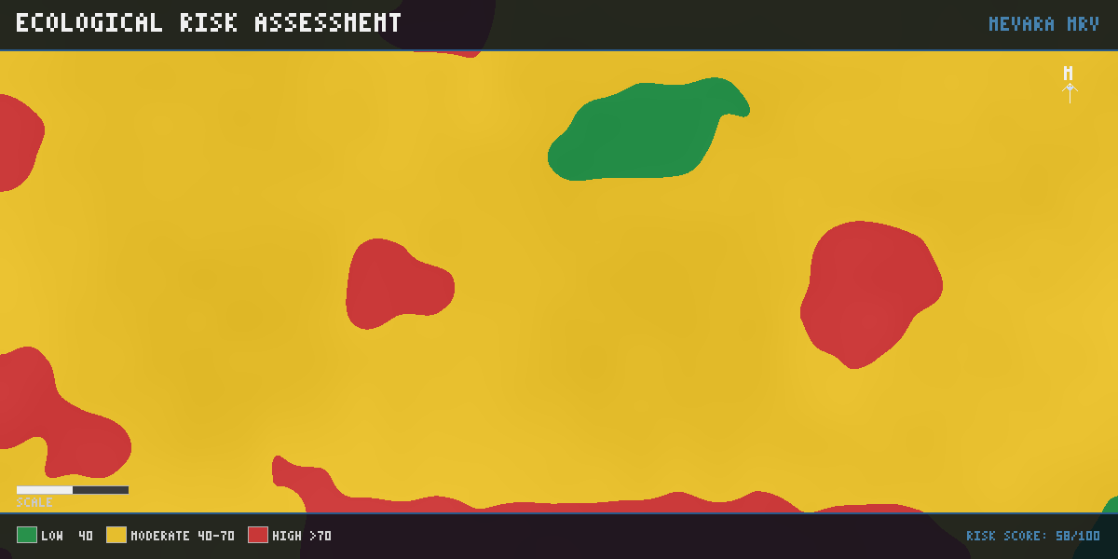
Figure: Figure 10 — Ecological Risk Map: Aggregated multi-domain risk indicators · Green = low risk (< 40), amber = moderate (40–70), red = high risk (> 70) evidence asset

11. Key Ecological Findings
The following structured observations were generated by the NEVARA deterministic rules engine from evidence metrics. Each finding is directly grounded in satellite-derived indicator values.
vegetation
Severity | Metric | Value | Finding | Recommendation | Confidence
high | vegetation.ndvi_mean | 0.1912 | NDVI_BELOW_VEGETATION_HEALTH_THRESHOLD | PRIORITIZE_FIELD_VERIFICATION_AND_REVEGETATION_PLANNING | 90
high | vegetation.ndmi_mean | -0.1927 | NDMI_INDICATES_VEGETATION_MOISTURE_STRESS | REVIEW_WATER_RETENTION_AND_SOIL_MOISTURE_CONDITIONS | 86
moderate | vegetation.bsi_mean | 0.2342 | BSI_INDICATES_ELEVATED_BARE_SOIL_CONDITION | TARGET_SOIL_STABILIZATION_AND_GROUND_COVER_REVIEW | 84

land use
Severity | Metric | Value | Finding | Recommendation | Confidence
low | lulc.vegetation_pct | 100 | LULC_INDICATES_VEGETATION_COVER_PRESENT | MAINTAIN_LAND_COVER_MONITORING | 80

historical change
Severity | Metric | Value | Finding | Recommendation | Confidence
moderate | historical.trend_direction | stable | HISTORICAL_NDVI_TREND_DOES_NOT_INDICATE_DECLINE | MAINTAIN_TREND_MONITORING | 84

hydrology
Severity | Metric | Value | Finding | Recommendation | Confidence
low | hydrology.runoff_risk | low | HYDROLOGY_RUNOFF_RISK_NOT_HIGH | CONTINUE_HYDROLOGY_MONITORING | 82
low | hydrology.hydro_stress_score | 12.25 | HYDROLOGICAL_STRESS_SCORE_REQUIRES_ROUTINE_TRACKING | TRACK_HYDROLOGICAL_STRESS_IN_NEXT_MONITORING_CYCLE | 82

restoration
Severity | Metric | Value | Finding | Recommendation | Confidence
high | restoration.suitability_score | 30.08 | RESTORATION_SUITABILITY_SCORE_IS_LOW | REVIEW_CONSTRAINTS_BEFORE_ACTIVE_RESTORATION | 80

risk
Severity | Metric | Value | Finding | Recommendation | Confidence
moderate | risk.overall_risk_score | 57.66 | OVERALL_ECOLOGICAL_RISK_IS_NOT_HIGH | FOLLOW_ASSIGNED_MONITORING_PRIORITY | 95

12. Recommendations & Actions
Evidence-based recommendations derived from this monitoring cycle. Vegetation cover is sparse: Investigate causes of low canopy density and consider targeted planting or protective interventions. Vegetation health is declining: Prioritise a field check to identify drivers of vegetation loss (drought, clearing, salinity, or grazing pressure). Water availability shows signs of stress: Assess hydrological inputs and consider whether supplementary watering or tidal/flow restoration is needed. Limited restoration suitability: Address limiting factors (moisture, soil, slope) before committing major restoration resources. Ecological risk is moderate: Maintain standard monitoring and track whether risk drivers trend upward in the next cycle. Increased monitoring frequency recommended: Increase the monitoring frequency for this project until risk indicators stabilise.
Priority Action Register — Critical & High Severity Findings
Metric | Value
Priority | Ecological Finding | Recommended Action | Urgency
1 | NDVI_BELOW_VEGETATION_HEALTH_THRESHOLD | PRIORITIZE_FIELD_VERIFICATION_AND_REVEGETATION_PLANNING | HIGH
2 | NDMI_INDICATES_VEGETATION_MOISTURE_STRESS | REVIEW_WATER_RETENTION_AND_SOIL_MOISTURE_CONDITIONS | HIGH
3 | RESTORATION_SUITABILITY_SCORE_IS_LOW | REVIEW_CONSTRAINTS_BEFORE_ACTIVE_RESTORATION | HIGH

13. Evidence Validation & Data Quality
All evidence assets in this report were validated through the NEVARA evidence validation layer prior to report generation. The following summary confirms data completeness and integrity for this monitoring cycle.
Evidence Package Validation Summary
Metric | Value
Status | warning
Score | 97
Validated At | 2026-06-12T08:02:58.423Z
Warnings | insights.json exists on disk but is not listed in manifest assets
Errors | None
Missing Assets | None
Generated Assets | boundary-overview.png, evidence-manifest.json, historical-trend.png, hydrology.png, insights.json, lst.png, lulc.png, metrics.json, ndvi.png, ndwi.png, observations.json, restoration.png, risk.png, true-color.png

